HOW TO USE “ZOOM” APP – A READY-RECKONER

Namaste! Remember, our meeting ID is: 873 298 732

Many thanks for agreeing to participate in the NRI-Natter series.

We shall be using the ZOOM app, which you may download and install on your PC, laptop, smartphone, tablet, phablet, or any other hand-held device you may use.

Please read the following guide to understand how to use ZOOM.

There are two ways you can use ZOOM.

1) Without registration or creating a User ID, you can simply login in to the ZOOM website and hook up live with the online meeting using
the Meeting ID: 873 298 732

2) You may want to download and install the ZOOM app first on your device, and create your own account by going through the registration process. We would recommend the second option. The process takes less than 2.5 minutes to 3 minutes.

OPTION 1
If you choose the first option, this is what you need to do:

If you are using your PC, Mac, Linux, iOS or Android device, use the following link: https://zoom.us/j/873298732

Follow these steps if you are using the first option:
- Open https://zoom.com/ or https://zoom.us/ (from China).

================ ============ ===========

2) In case your browser picks up the Chinese version of the site, please scroll down to bottom of the page and change language from the drop down box
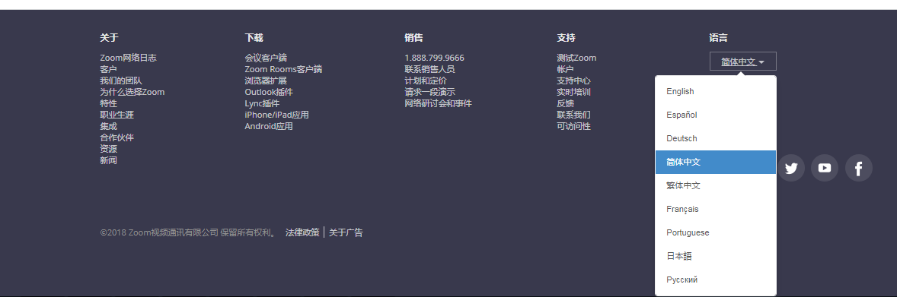
================ ============ ===========
3) You can join a meeting directly by just clicking on “Join a Meeting” with the Meeting ID provided to you

================ ============ ===========
4) While launching the meeting, you will be prompted to download & run ZOOM plug-in as seen in the screen below. 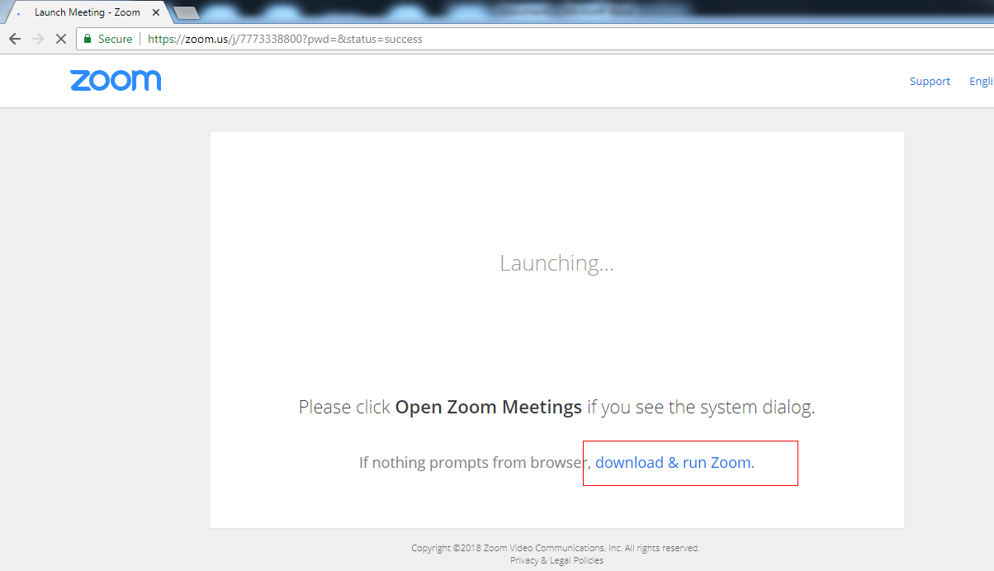

================ ============ ===========
OPTION 2
If you wish to use the second option (app download), follow these steps:
4) First visit the ZOOM website. You need to download “Meetings Client” on your device. See links in red boxes in the image below.
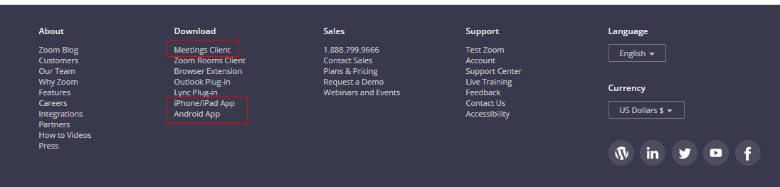
5) Open the .exe file and Click on “Run”.

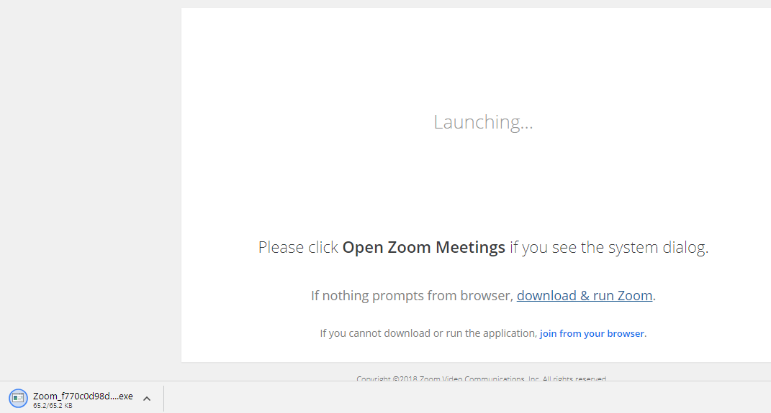
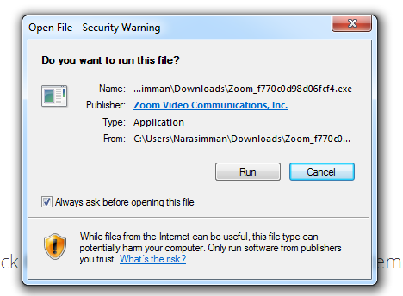

6) That will install the app on your device. Next, you need to double-click on the app icon your desktop screen / device screen. That will launch the app, and you will see the following interface. Click on “JOIN”.
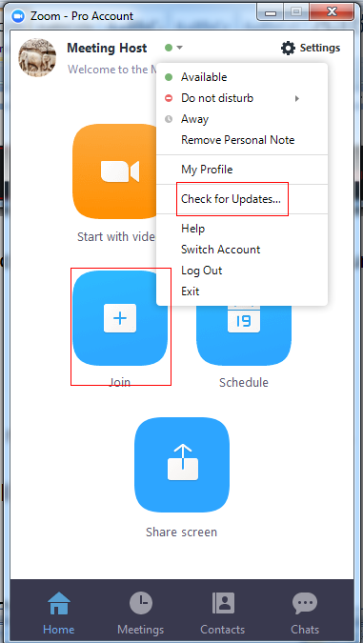

7. You will reach the following interface. It has a menu with audio and video control features. 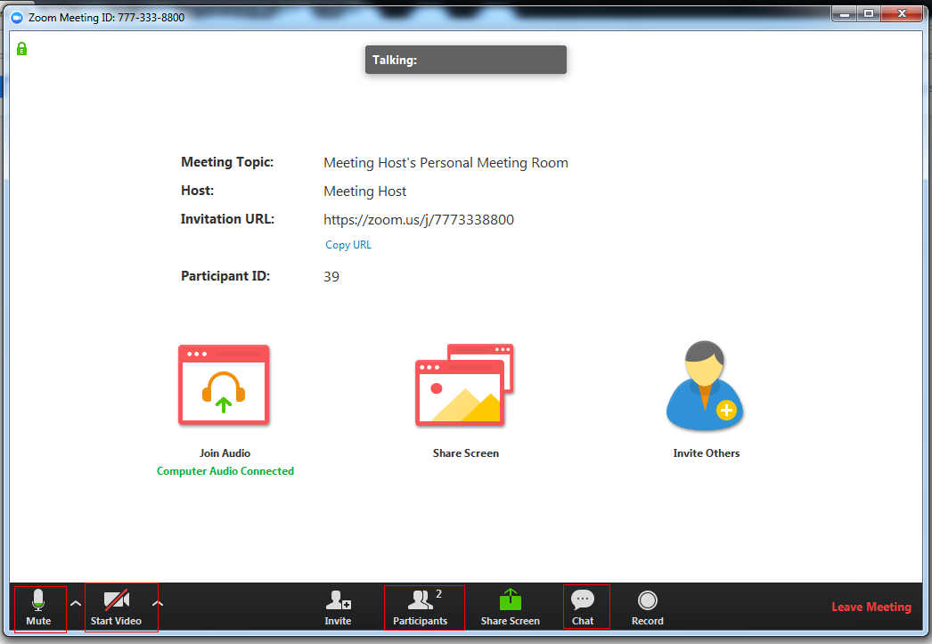

Some of the commonly used features are:
Mute: To Mute/Unmute yourself during the meeting; please remain on mute when you are not the speaker.
Start/Stop Video: To start video streaming from your device and be visible to all participants, tap on this button. It’s a toggle switch. So, press the same button again, to stop video streaming.
Participants: This will show you the number of participants in the meeting at any given moment.
Share Screen: If you wish to share a document, PPT, video or audio on your device screen, click/tap this button. Other participants will be able to see your content.
Chat: Click on this feature to send simple SMS-like text messages in real time. In the Chat window, you can make use of file-transfer feature to share files.
For more help, click on help on Zoom home page or call/message the Meeting Host/Moderator.

Thank you!

